**Laboratory 1**

In this lab sheet I will be using vmware to install microsoft windows 2016 server, datacenter edition. Because I'm using A2.NET I will login using the vm account allocated to me. In this case vm1.

To download the windows server image file i will run the following command in the terminal.



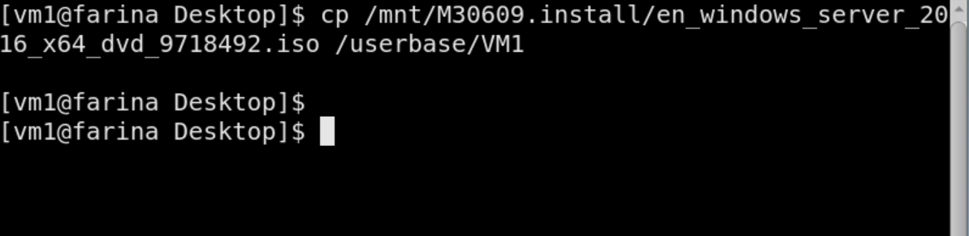

Now it has finished downloading. I will begin creating the virtual machine and installing the windows server 2016.

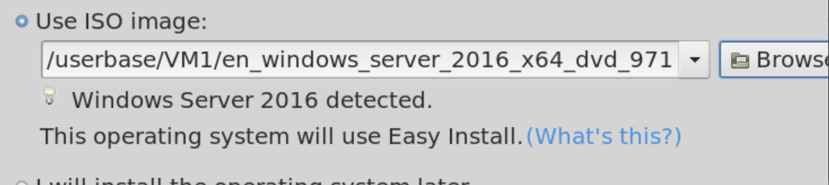

Here I select the iso image and browse for the file.

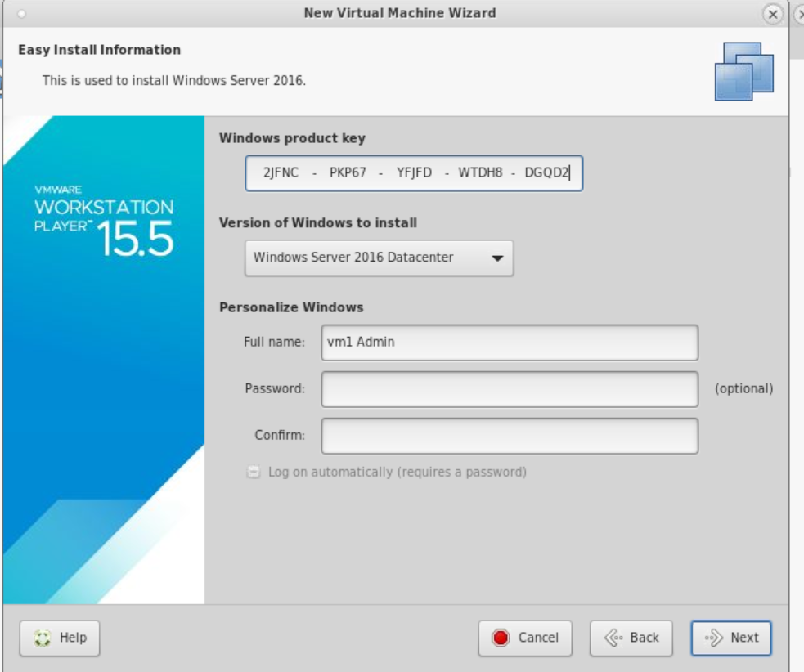

Here i enter the license key

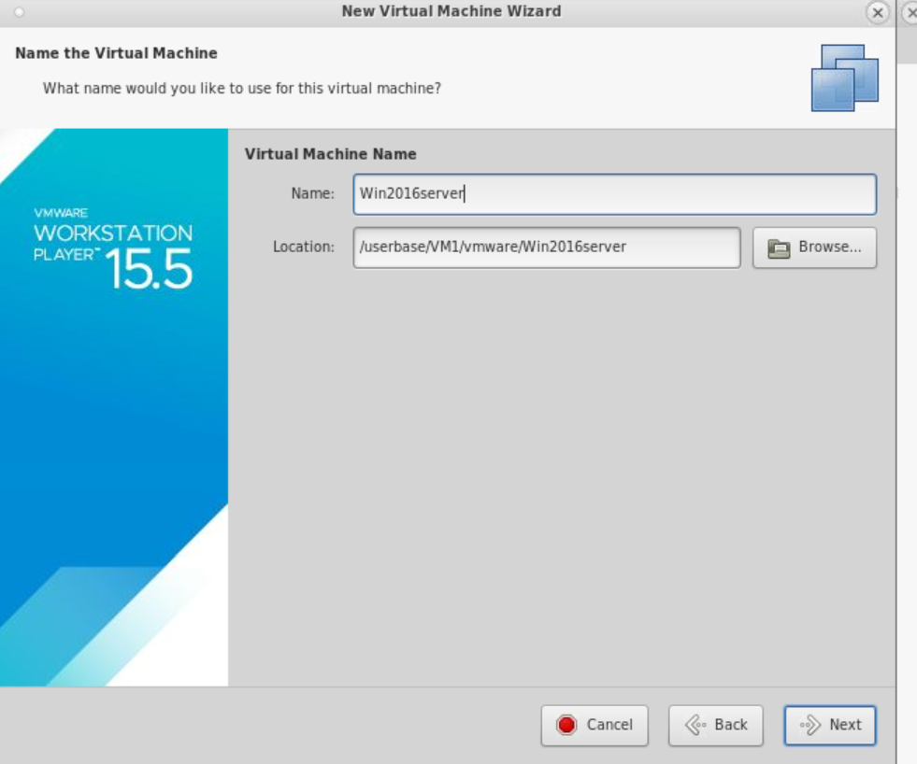

Here i change the server name to win2016server

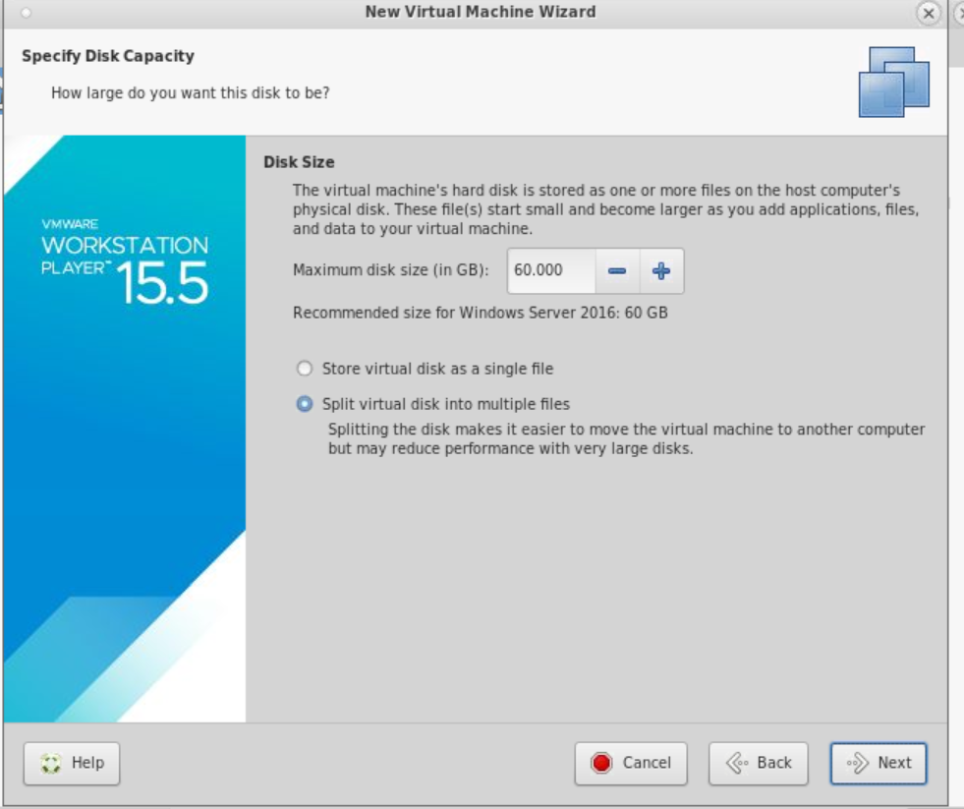

I make sure to allocate 60gb to the machine.

After waiting for it to install and setup, it was now completed.

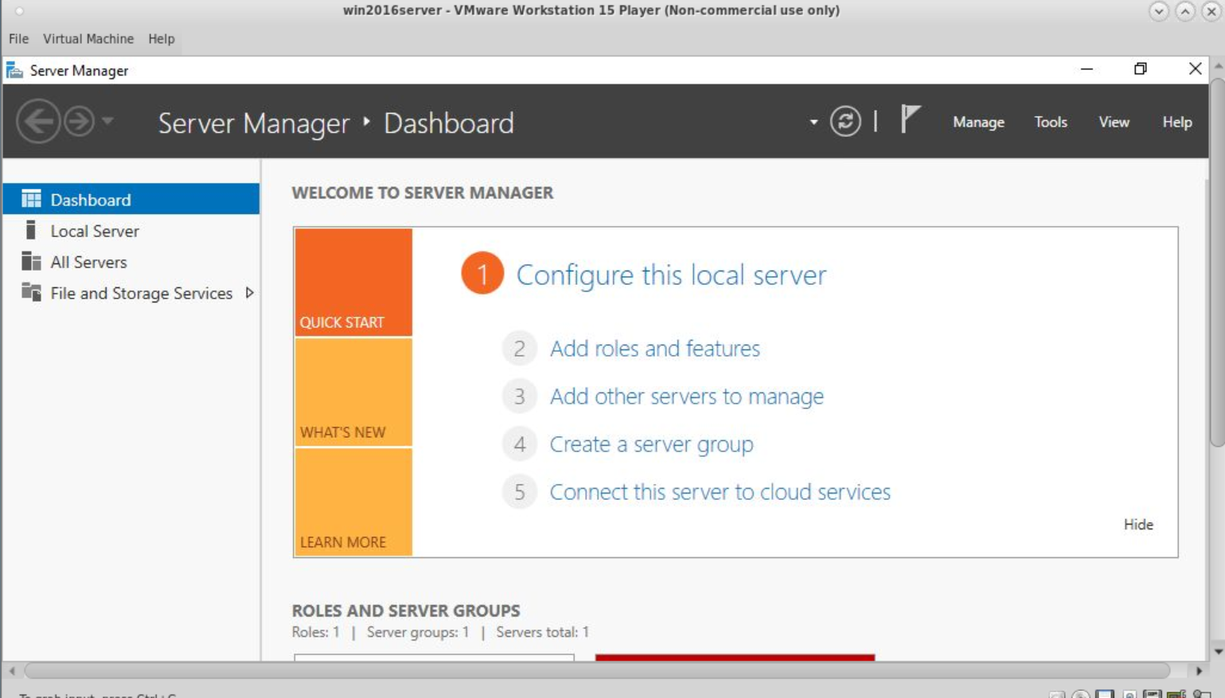

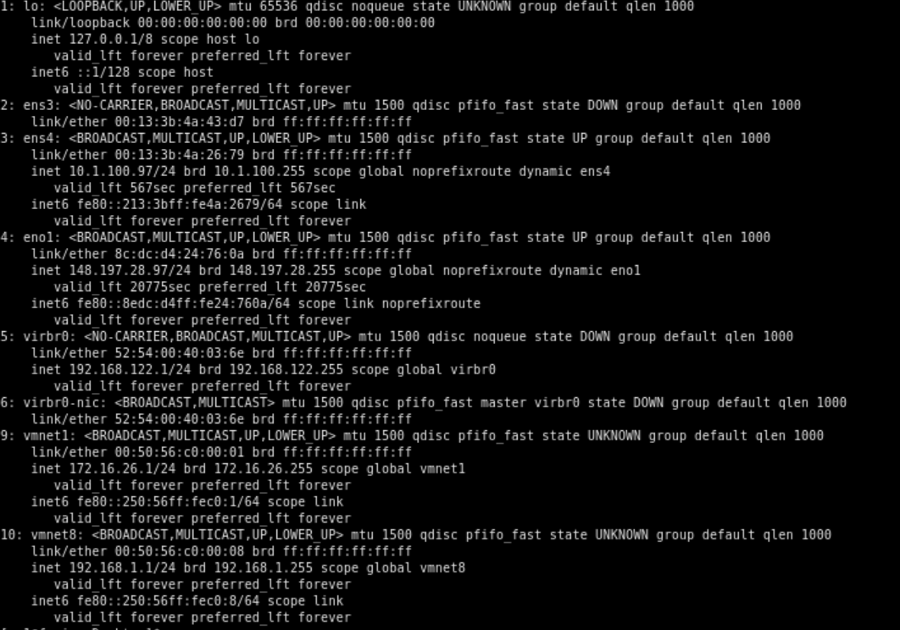

Here I run ipconfig to check that the correct ip is assigned.

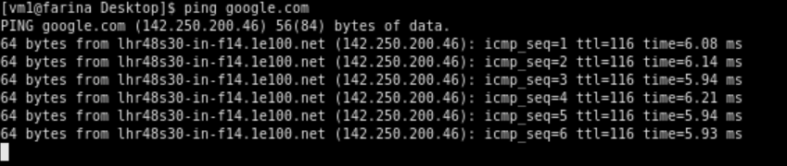

I then check to see if I can ping google and it's successful.

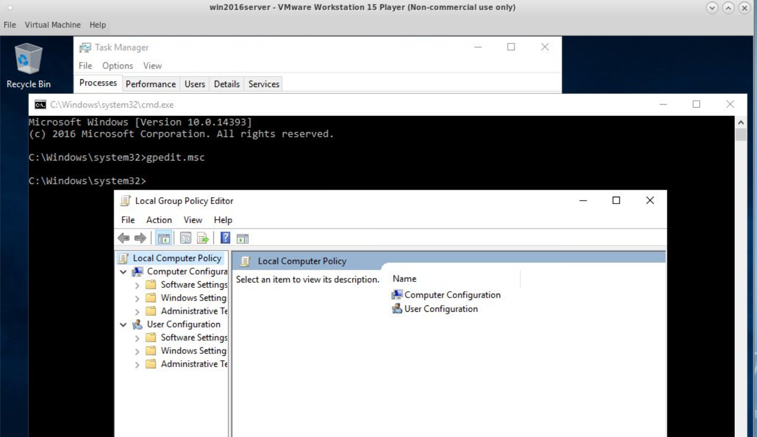

Here I navigate to the windows 2016 group policy editor.

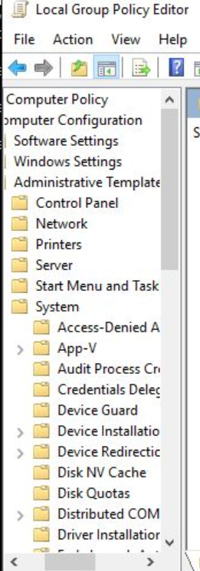

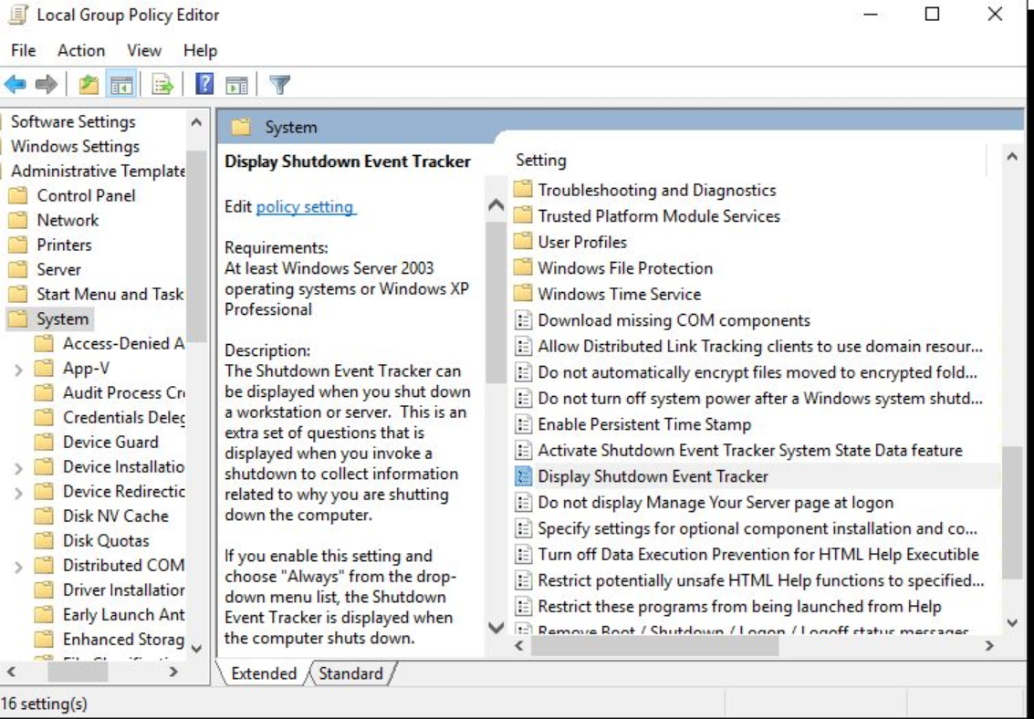

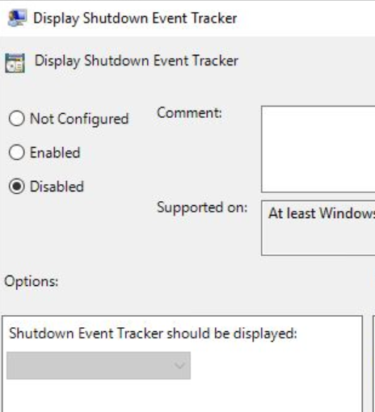

I disable the settings. This is so that windows don't question me every time i want to reboot or shutdown the server.

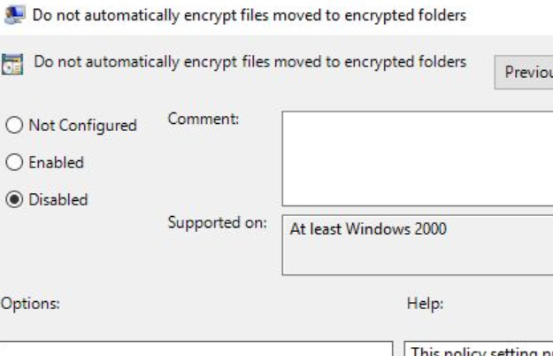

From looking at the group policy editor another another policy that can be changed is the do not automatically encrypt files moved to encrypted folders policy. By disabling this it means files that are moved to encrypted folders are encrypted automatically and I won't have to do it manually.

From the screenshots above the virtual machine name is already called win2016server. From this labsheet I was able to create a new virtual machine and download and install the windows 2016 datacenter server onto the virtual machine.

**Labsheet 2**

In this lab sheet I will be installing and configuring dns in windows server 2016. I will be setting up the dns for the domain name testdomain2005634.com.

First i will be installing the dns in the windows 2016 server. I first launch the server manager and on the manage menu I click add roles and features.

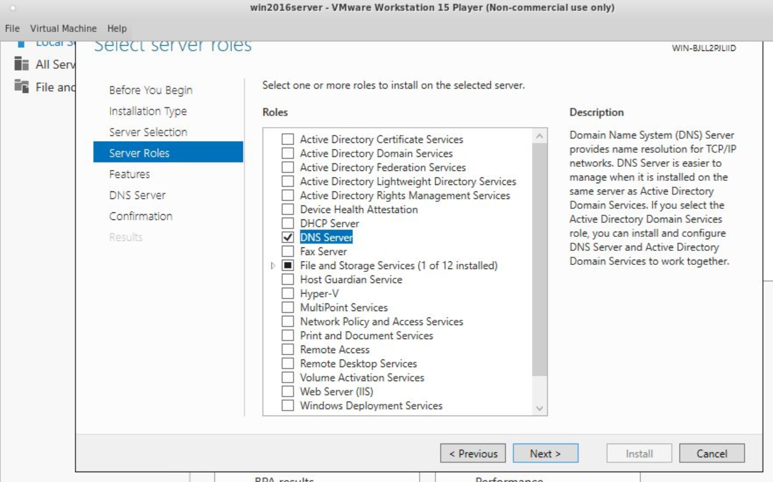

I then select the dns server role checkbox and click next.

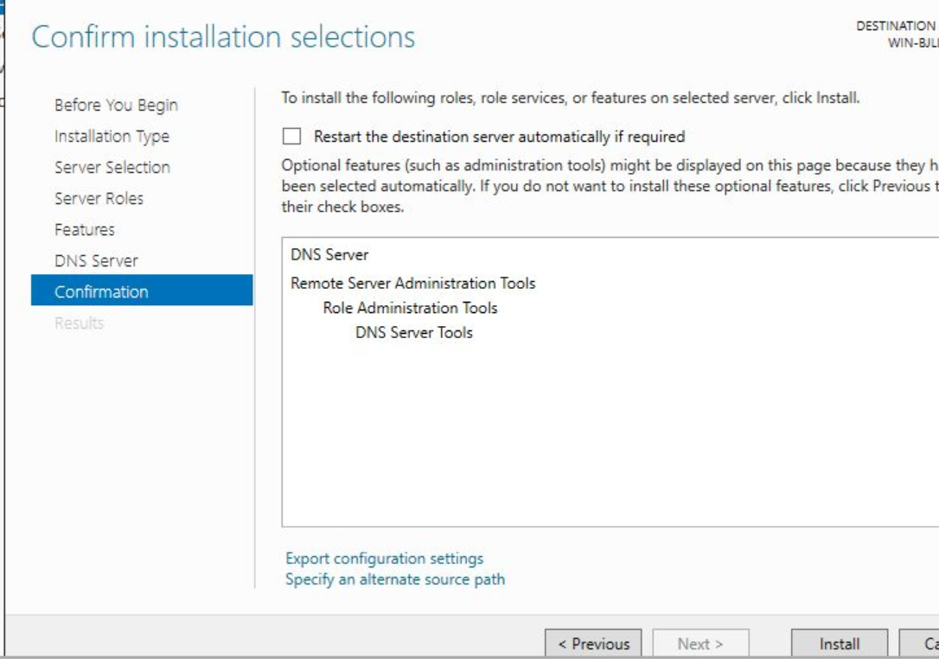

I then click install.

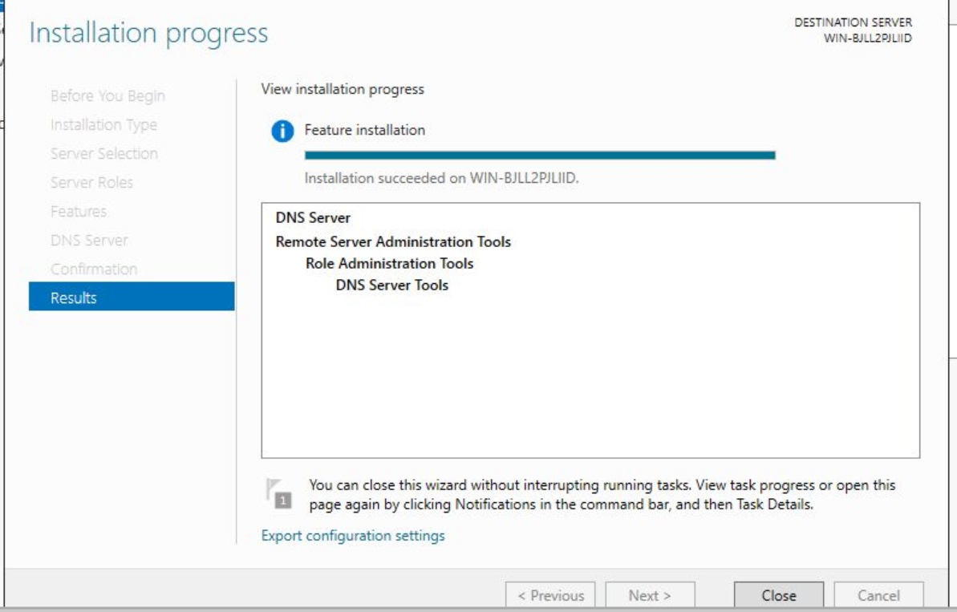

Now that the dns is installed I now need to configure it. After which I go back to the server manager, click the tools menu and select dns. I go to the configuration window and right click forward lookup and then click new zone.

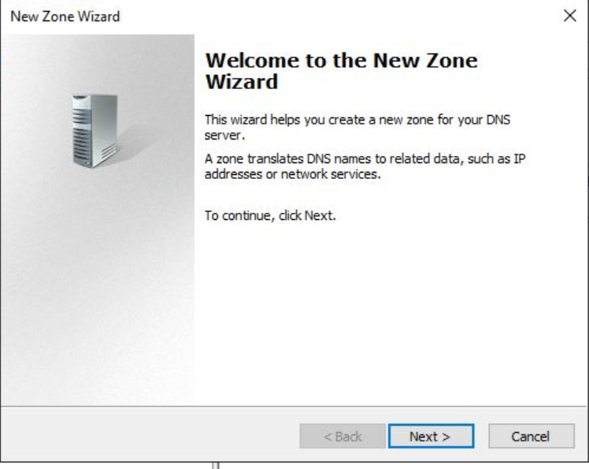

Here it will begin to guide me on how to create a new zone.

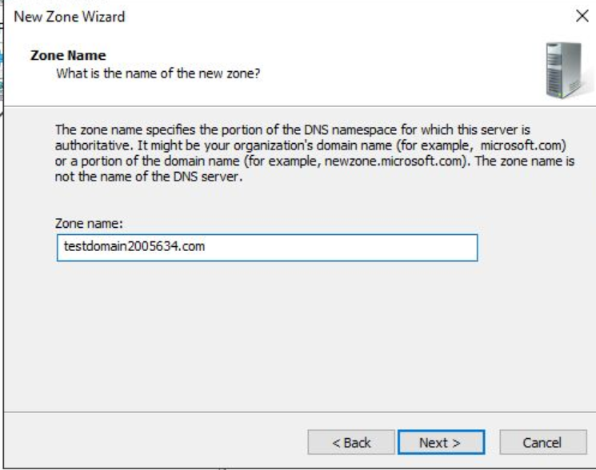

Here in the domain name i enter testdomain2005634.com. Because that's my student id number.

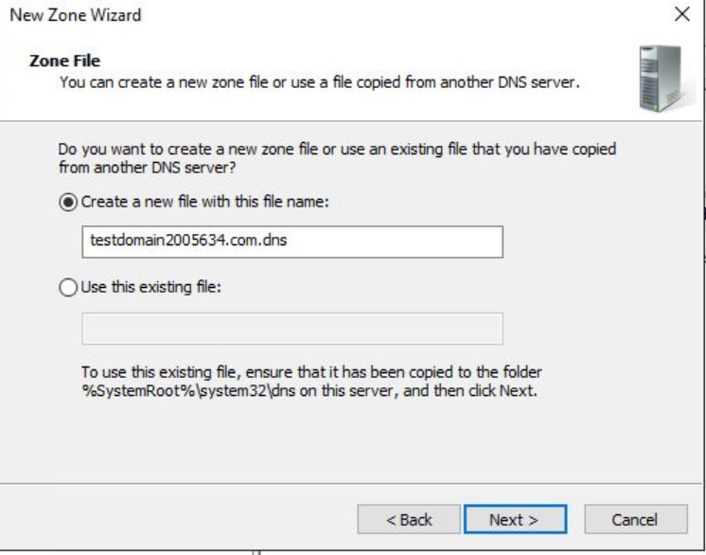

Here I accept the default file name that's presented and click next.

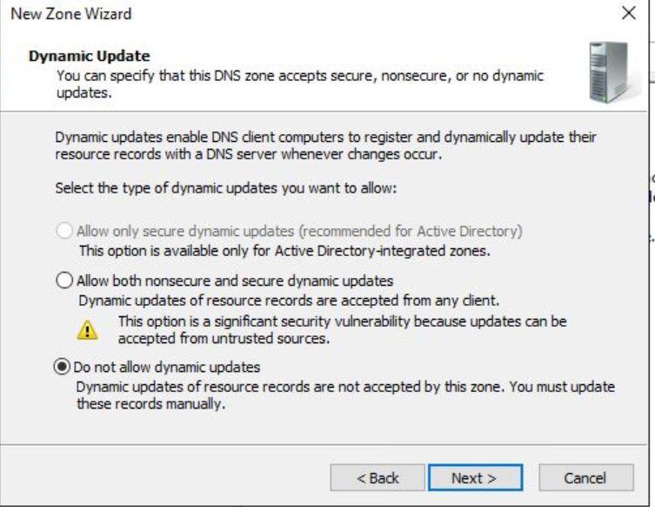

I accept the default option.

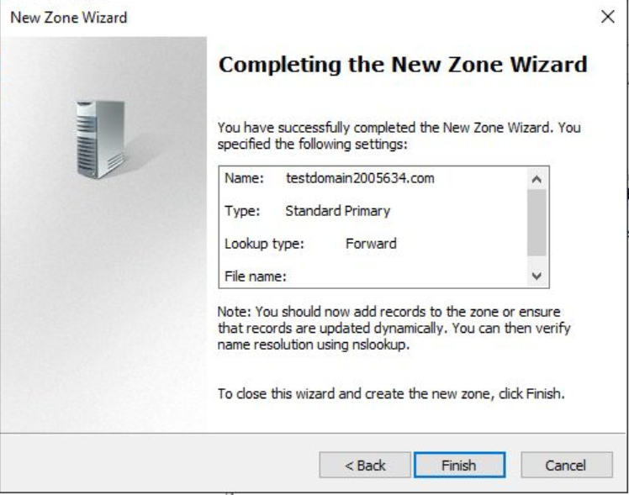

ThenIi click finish.



Here we see the file created however its a blank file but i will fill it with zone information later.

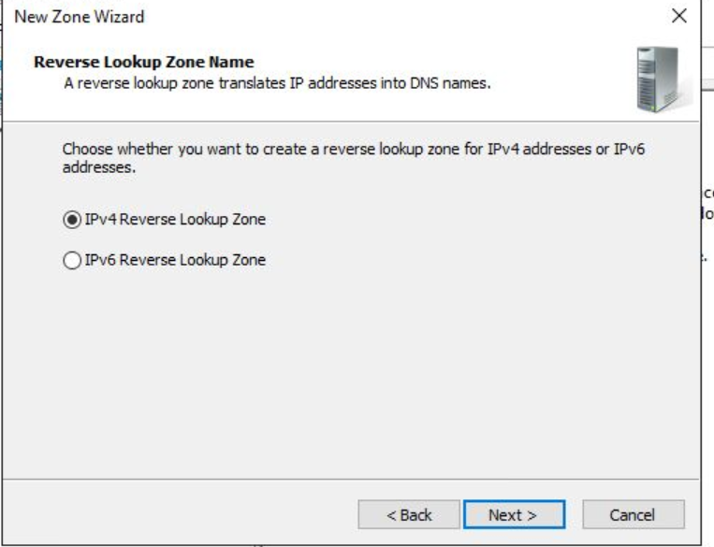

Here I repeat the same process when creating a reverse lookup zone.

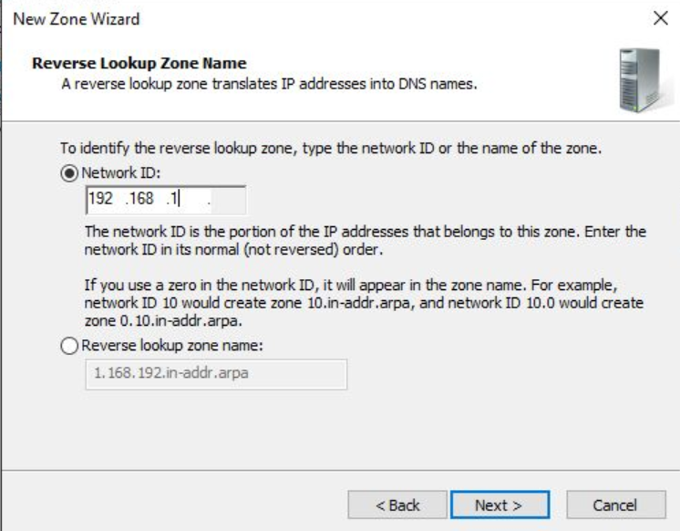

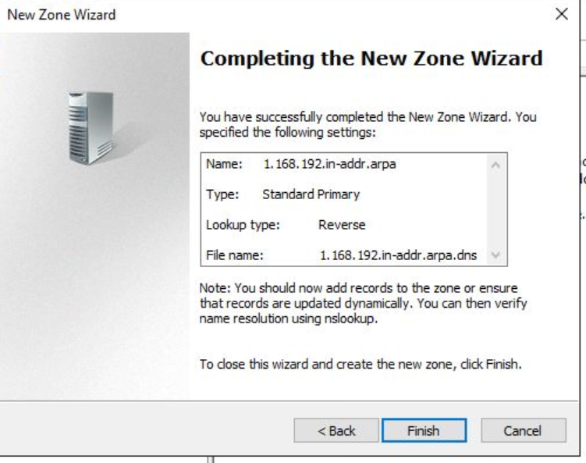

Here I finish the process for the reverse file.

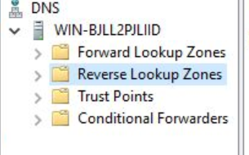

Now that I have created the forward and reverse zones files it's now time to configure them. To do this I will need to add host records.

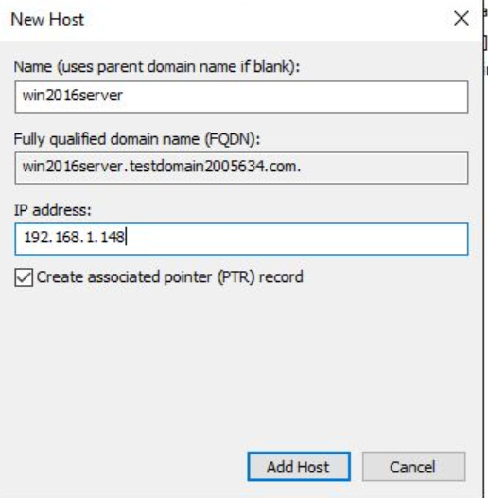

I right click on testdomain2005634.com and select a new host. I then enter the name of the computer and my ip address.

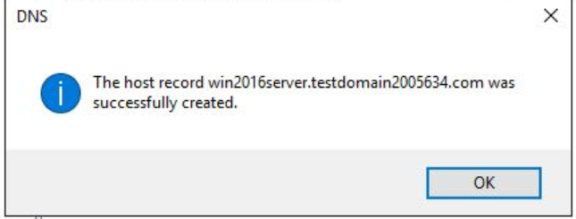

Here it has been successfully created.

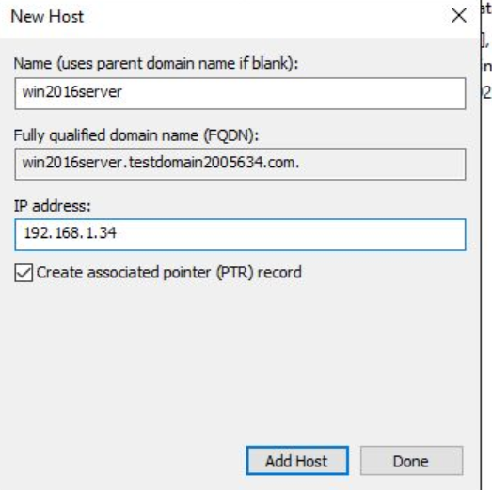

I repeat this process and replace the last two digits of the ip address with the last two digits of my student id.

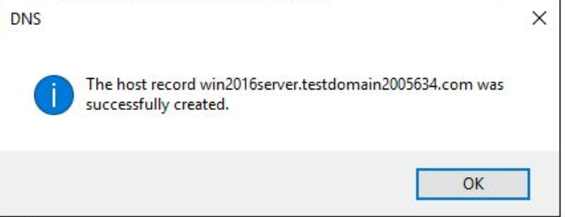

Now my next task is to configure the SOA and name server sections of the zone file.

Start of authority is a resource record in the dns that contains administrative information about the zone. All zones need a soa so that it conforms to IETF standards.

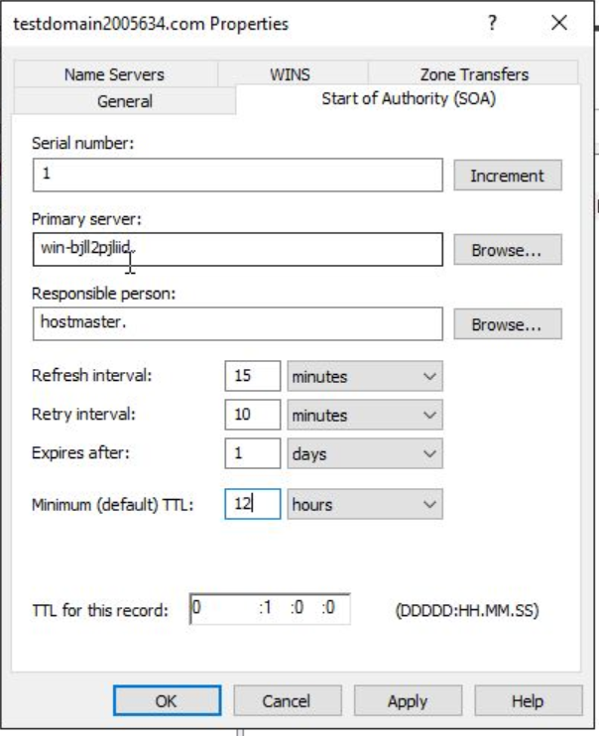

Here I set the ttl to 12 hours. Ttl stands for time to live and is responsible for telling the server how long it should keep a record in its cache. By setting it to 12 hours, it means the server will hold the information for longer.

My next step now is to add client side dns in windows. I have to configure the windows computer in order to use the dns server i just created to resolve names.

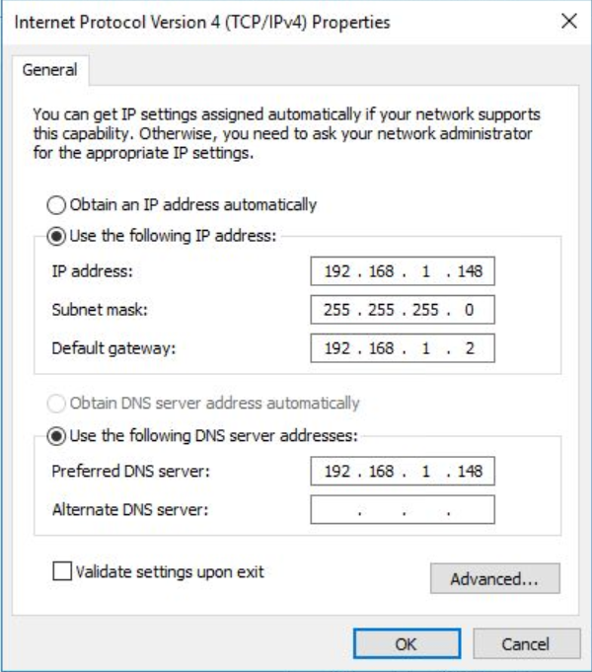

Here I enter my ip address as the primary dns for the tcp/ip settings.

To see if the dns is working i will use a basic tool called ping.

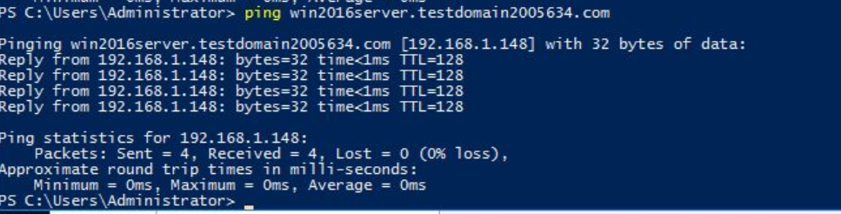

As we see above have successfully been able to ping the dns using the domain name..

To see if the dns can properly translate a host name into an ip address I will also use nslookup. Nslookup command is used to find the host or domain name that corresponds to an ip address. Below as you can see it presents to me the correct ip address that i set for the domain names.

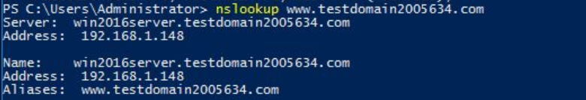

Here we see the domain names and the ip address that I configured them with being successfully presented.

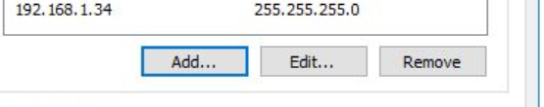

Now I will be adding an extra host staff for the teaching ip I set up earlier. To do this i added my ip address to the computer as shown above. I will now use nslookup to see if the ip address has been configured correctly to the teaching domain.

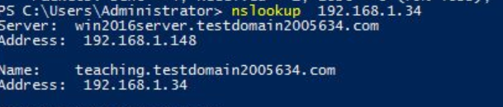

As shown above using nslookup it has been successfully translated to the correct dns domain name.

To register a domain name for example www.spencer’shousingcompany.com, I will need to go to a domain name registrar. This is a company that handles domain name reservation and the allocation of ip addresses. The cost of this can range anywhere from £6 to £70 or possibly more.

The rules for registering in the domain names in the .pro TLD are you must provide a professional service, be admitted or licensed by a government certification body recognised by the government and be in good standing with the licensing authority. My friend that is a professional wrestler cant register a .pro domain as they don't provide a professional service.

From this labsheet I have been able to install and configure a dns in windows 2016 server. I have also been able to troubleshoot a dns to ensure that the correct ip address is configured to the correct domain name and that a domain name correctly matches an ip address.

**Labsheet 3**

In this lab sheet I will be undergoing the basics of how to set up and manage a web server in particular, microsoft internet information services.

First I will need to install microsoft's internet information services. First I will need to log onto the windows server as a local administrator.

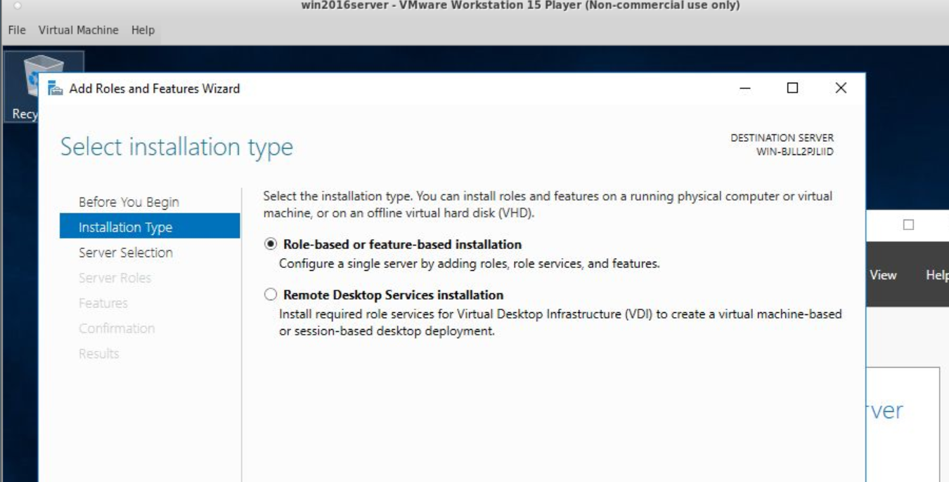

I then launch the server manager,select add roles and features, then i select role-based or feature-based installation.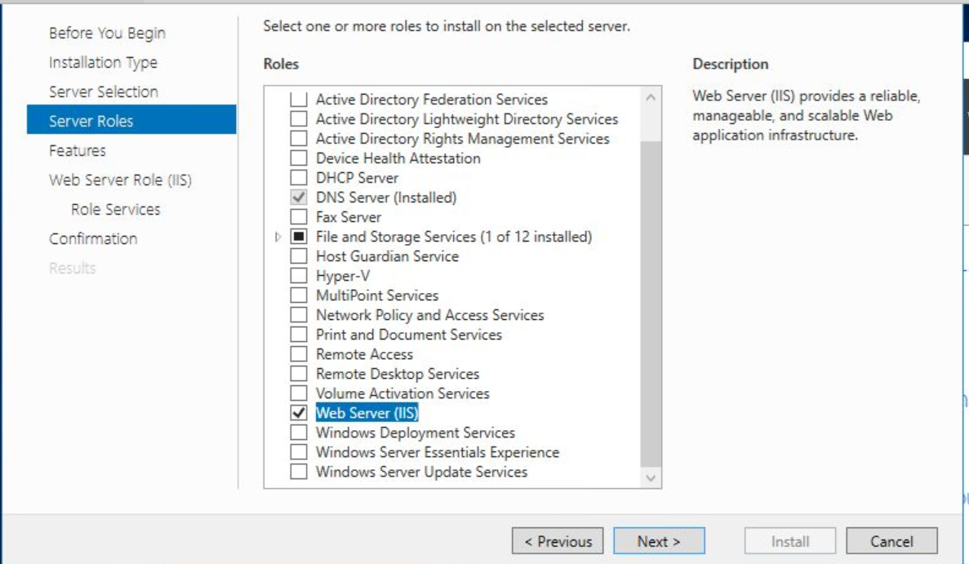

I then select the web server(IIS) in the roles section.

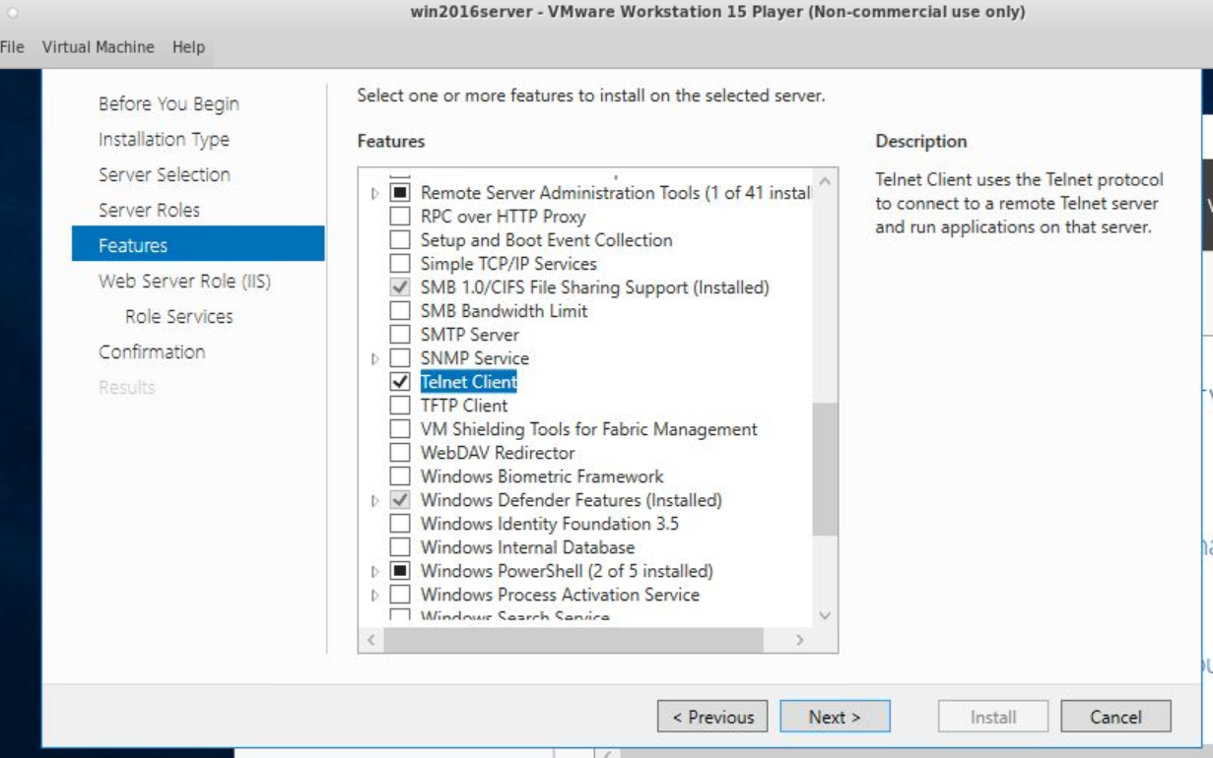

Then I select the Telnet client box in the features section.

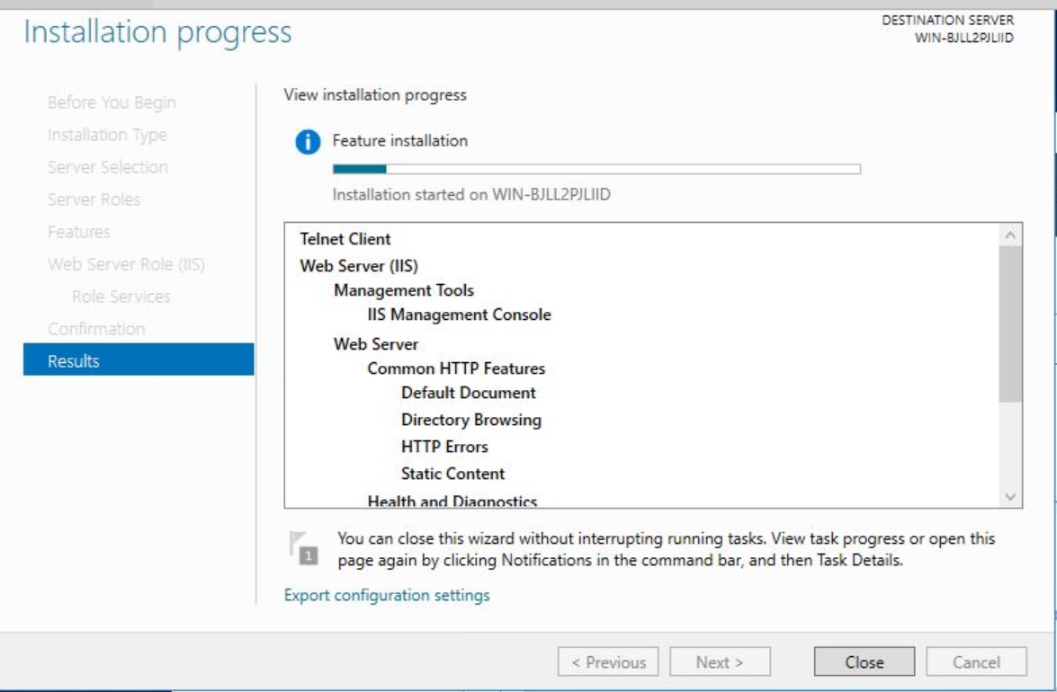

Finally I clicked install and waited for it to be downloaded. When it finished downloading the new menu item ISS was added.

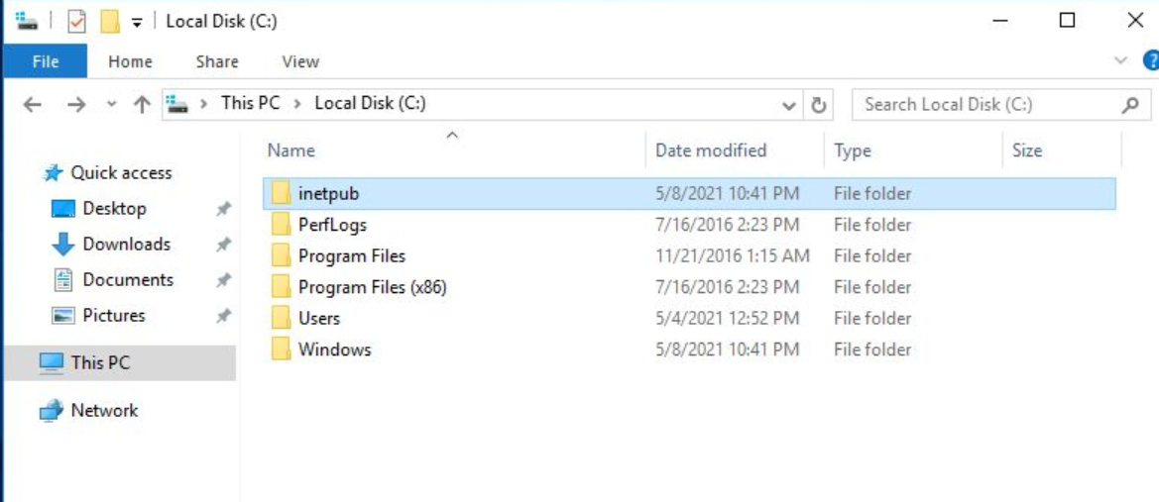

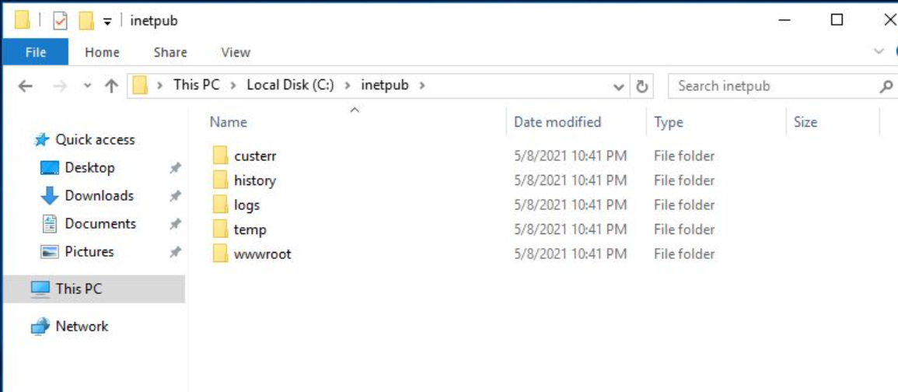

Furthermore a new folder called Inetpub was created. It contains subfolders and within the wwwroot subfolder is where i store my webpages. I will be using the internet explorer to test my web pages.

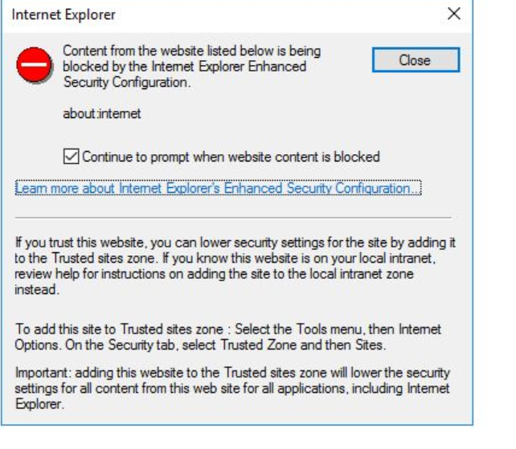

Before testing I will be disabling the enhanced security configuration so that the content won't be blocked.



I launch the server manager and click configure this local server. I then select on to open the configuration dialog.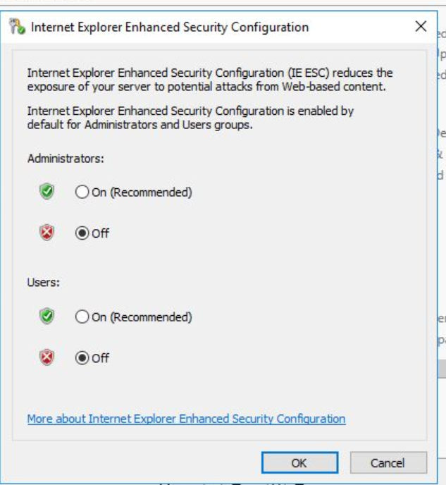

Here I've turned off the setting for administrators and users.

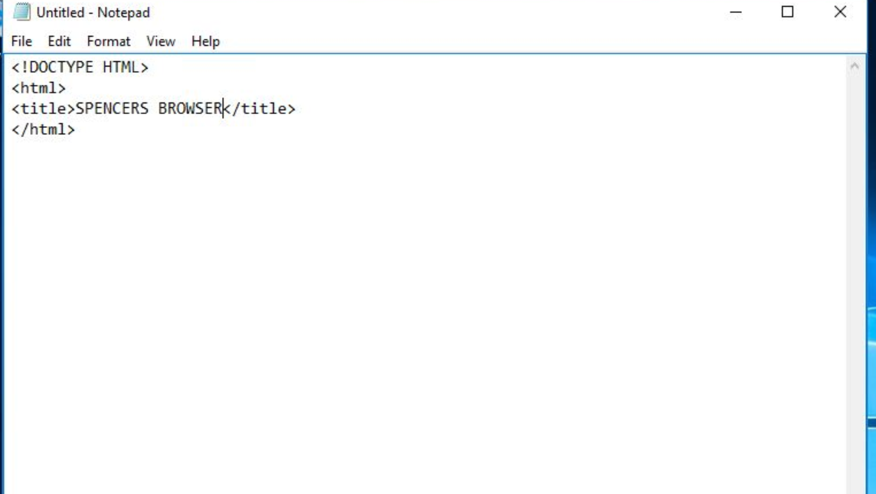

I then proceed to create a html document. I name it default.htm and save it in the root subfolder.

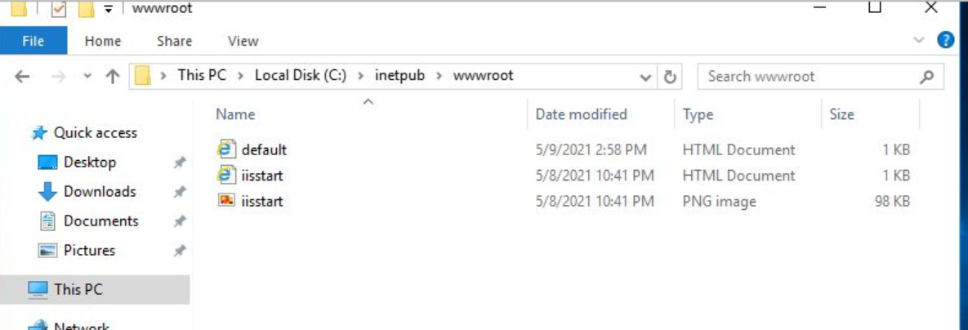

After this I launch the IE application and enter this in the url.



The name localhost is a special internet name that always refers to the computer that you are using. This is ideal for testing web sites.

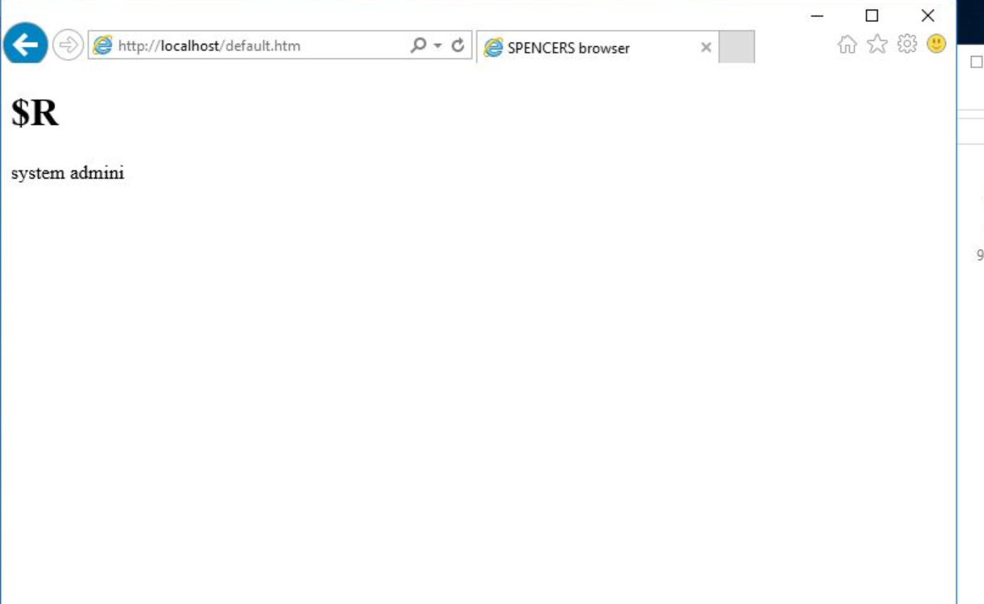

As presented above the webpage that I just created is successfully displayed.

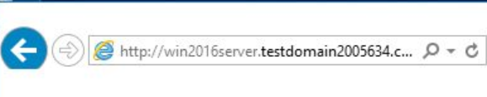

I then proceeded to enter my host name in the url. If the dns is successfully installed, it should also upload the webpage I just created.

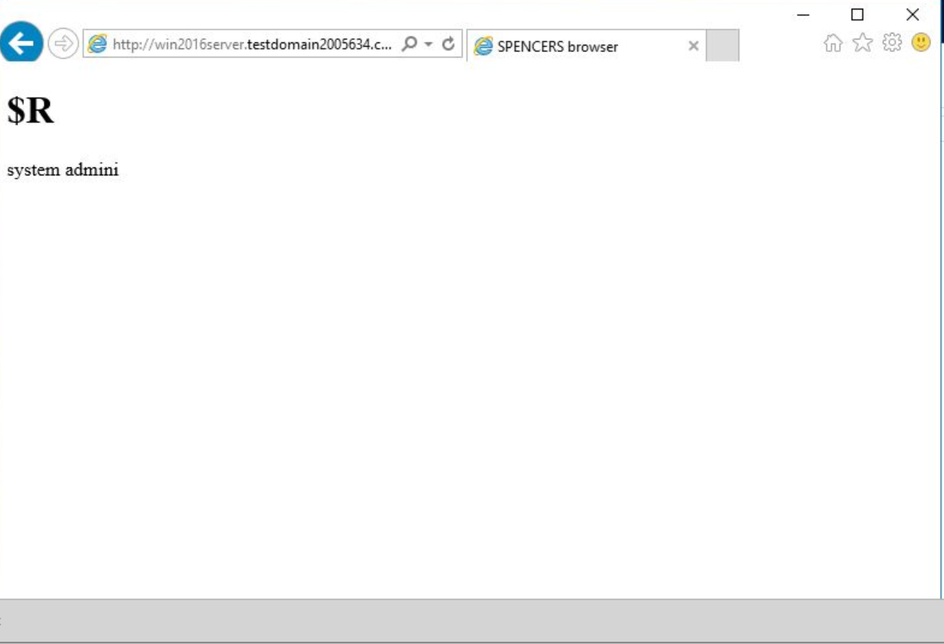

As presented it was successfully uploaded as well.

Now I will proceed to building a simple website on the computer.

Web servers usually organise sites into virtual directories. A virtual directory is a section of a website that appears in a URL but doesn't necessarily relate to a real directory on the computer.

First I will setup a virtual directory called “tests”.

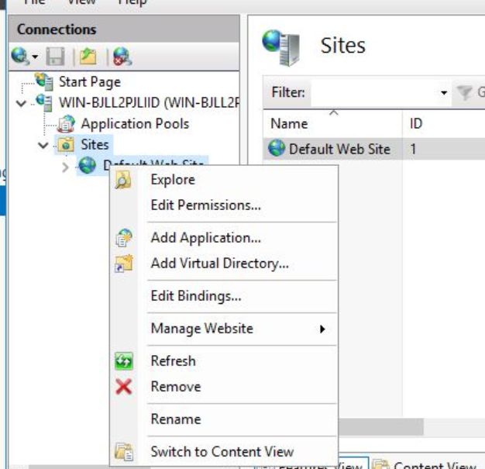

To navigate to here I select IIS from tools double click on win then I open the sites folder and right click on default web site.

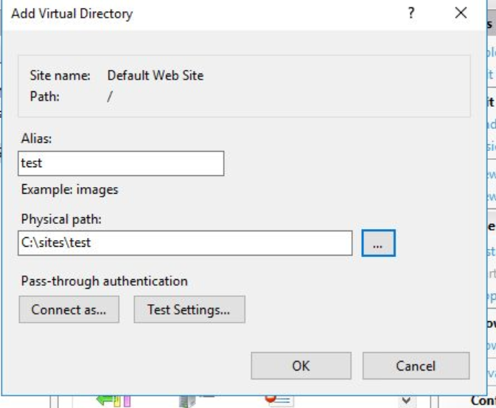

Here I set the alias to test and browse the folder that I previously created for where it will be stored. I click ok and now I've created a virtual directory in IIS.

Now I will proceed to create another html document.

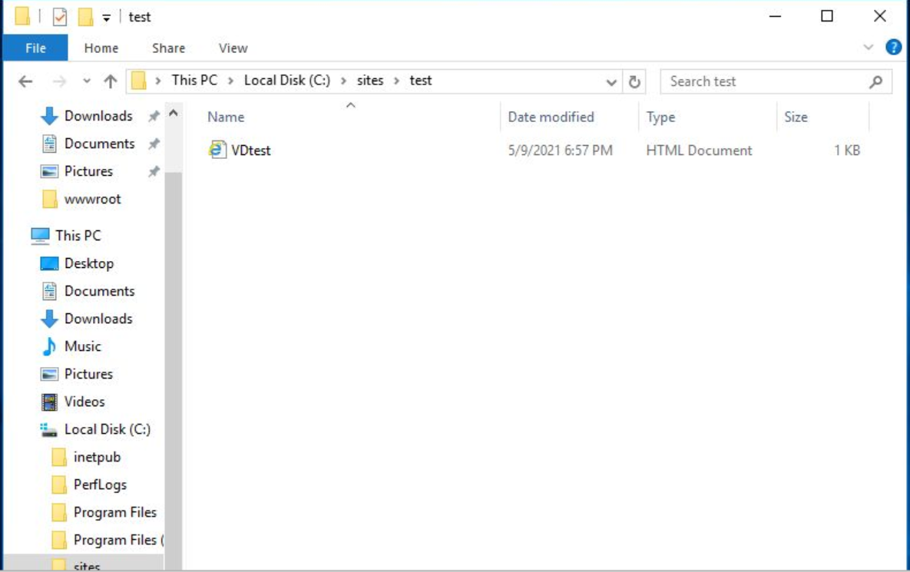

Here i've created the new html document and saved it in the C:\Sites\test folder.

I then open a web browser and type in the following url link at the top



I replace the asterisks with my student ID number.

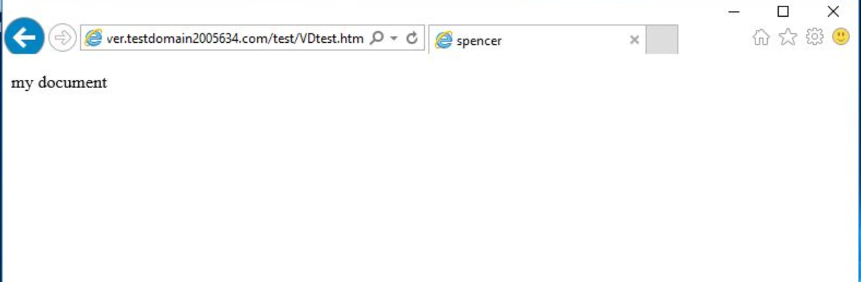

As presented in the screenshot when I enter the url link it brings up the webpage that I just created.

Virtual directories are useful as it allows for faster deployment. It can also be used to secure all backend storage locations with a single security policy.

Now I will be adding the canonical name www for the website. To do this I will need to configure the dns to add the CNAME record.

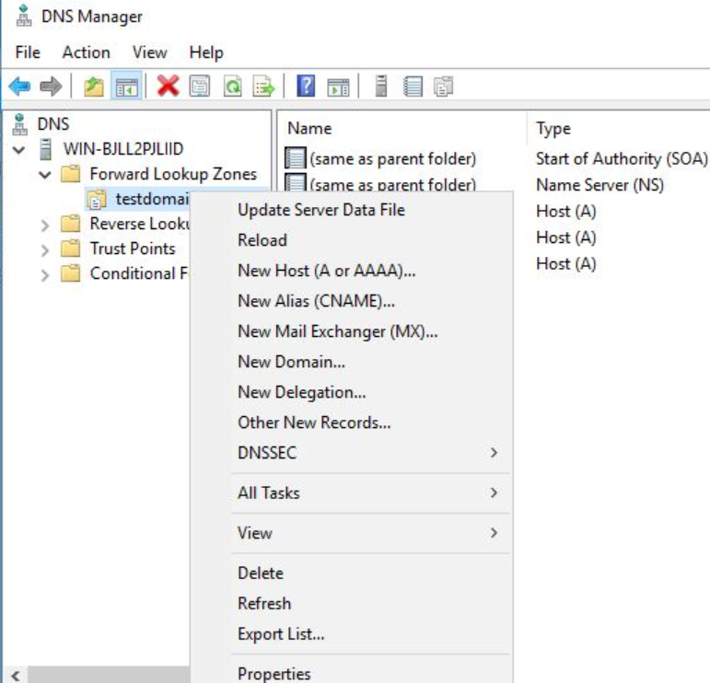

I right click on testdomain and select new alias CNAME.

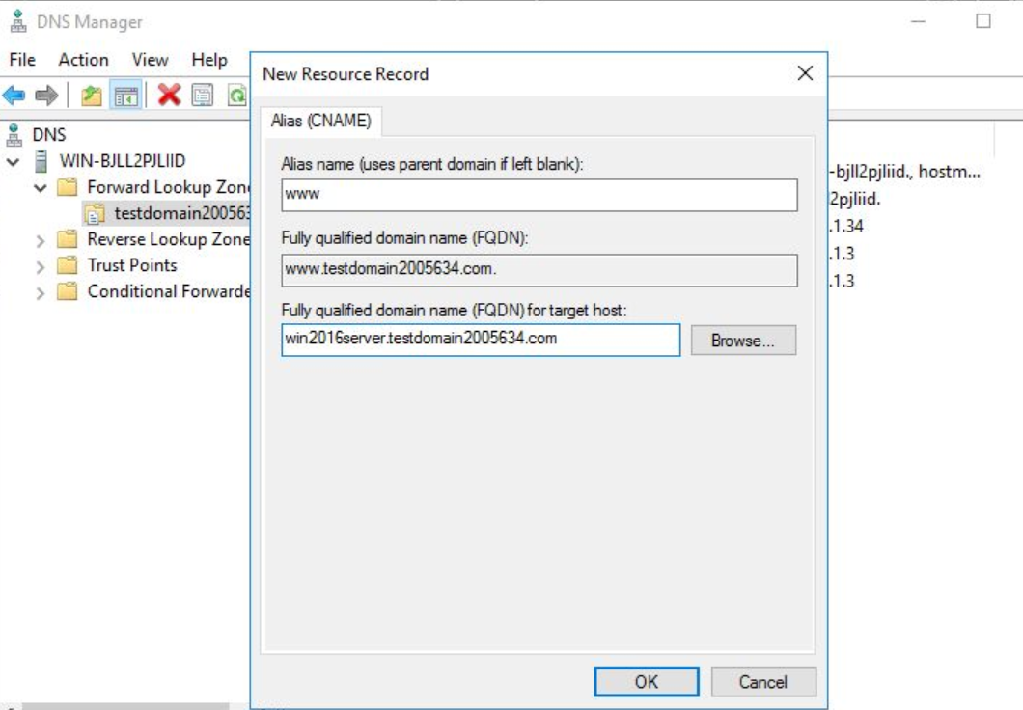

I then enter www as the alias name and win2016servertestdomain2005634.com as the FQDN.



I then proceed to enter the url into the web browser.

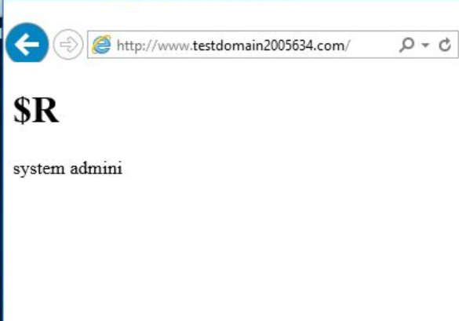

As shown above it loads the webpage that I created earlier.

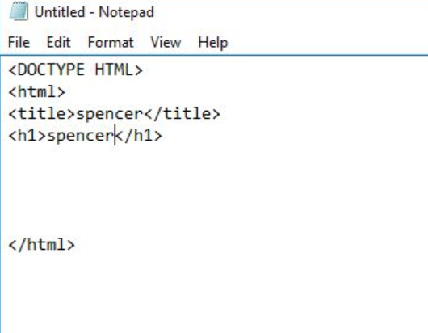

I then proceed to create another html document.

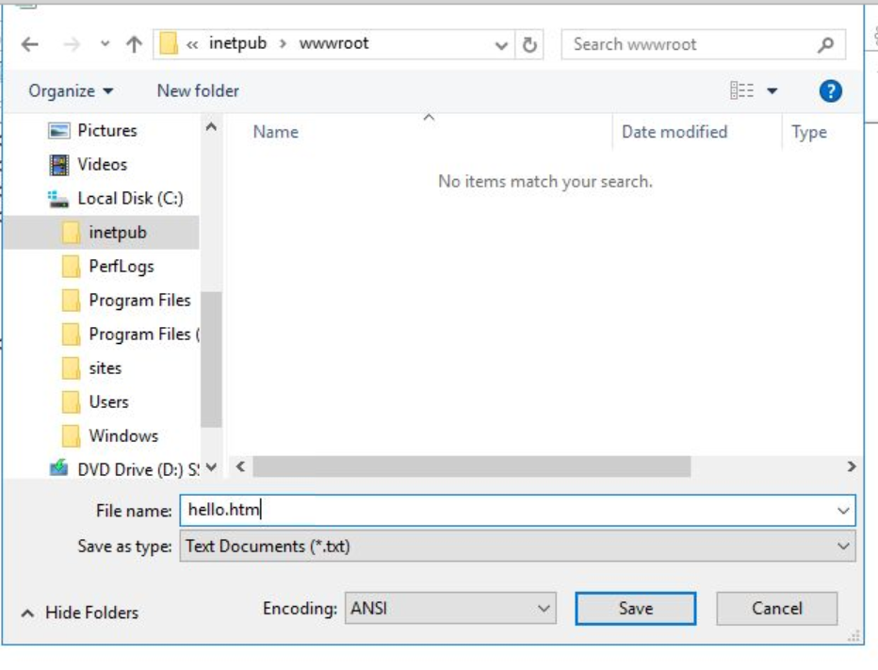

And I save it in the \inetpub\wwwroot folder.

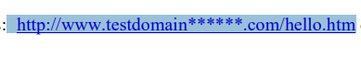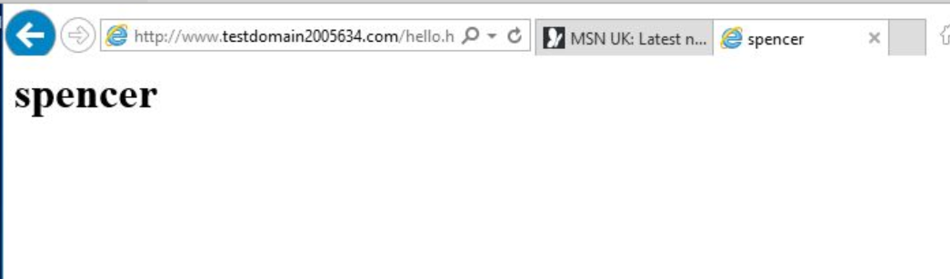

I then enter the above url in the browser and it successfully loads the webpage that i just created.

From this labsheet I have been able to install IIS, and build and manage web servers. Furthermore I have also been able to use internet explorer in order to test that my webpages are loaded correctly by using different urls to link to the web pages.

**Labsheets 4-5**

In this labsheet I will learn how to manage a IIS web server. I will also be configuring a file transfer protocol server in windows to let others transfer files to and from my web environment.

**Examining IIS properties**

Normally for the settings in IIS, windows will set up the majority of the configuration settings that meet most demands of web sites. However as the website grows and changes, I will probably need to adjust the settings and other properties of IIS. In this section of the labsheet I will examine and learn how to change IIS properties.

IIS can be configured by navigating through the IIS manager snap in. This can be accessed by selecting server manager, tools and then IIS manager.